**CONTENT**

|  |  |  |
| --- | --- | --- |
| **S.No.** | **CONTENT** | **PAGE No.** |
| 1. | Abstract | 2 |
| 2. | Project Overview | 3 |
| 3. | System Design | 4 |
| 4. | Input Design | 8 |
| 5. | Output Design | 8 |
| 6. | Menu Level Description | 9 |
| 7. | Process Specification | 10 |
| 8. | Screen Layouts | 11 |
| 9. | Conclusion | 13 |
| 10. | Bibliography | 14 |

**ABSTRACT**

# The Online Bus Pass Management System is a user-friendly and efficient web-based application developed to streamline and automate the process of applying for and managing bus passes for students, professionals, and daily commuters. Designed to eliminate the inefficiencies associated with traditional, manual systems, this platform allows users to easily apply for new bus passes or renew existing ones from the comfort of their home, reducing time spent waiting in queues.

# The system provides a well-organized interface for both users and administrators. The user dashboard enables individuals to submit their applications, upload required documents, and track the status of their bus pass requests. The admin dashboard empowers administrators to review and approve applications, manage pass issuance, and update system data in real-time.

# The platform is built using modern web technologies such as HTML, CSS, and JavaScript, ensuring a responsive, scalable, and cross-platform compatible solution. With its intuitive design, the system simplifies public transport processes, making bus pass management quick, convenient, and efficient.

# By moving the bus pass process online, the system improves operational efficiency, reduces administrative workload, and enhances user experience. This digital transformation not only saves time but also ensures transparency and accuracy in the issuance of bus passes. The system's modular design allows for future scalability, supporting additional features like integration with payment systems, mobile access, and automated reminders for renewals.

# In summary, the Online Bus Pass Management System significantly enhances the public transport experience, contributing to smarter, stress-free travel and improved management of bus pass operations.

# INTRODUCTION

### PROJECT OVERVIEW

## The Online Bus Pass Management System is a modern, user-centric web application designed to streamline and automate the process of bus pass issuance and management for students, professionals, and daily commuters. This system aims to replace the traditional paper-based bus pass system with a centralized, digital platform where users can apply for new passes, renew existing passes, and track their application status in real-time, making the entire process more efficient and transparent.

## The system allows users to fill out an application form with key details such as name, contact information, pass type, and route information, along with uploading required documents. The form is validated to ensure the accuracy and completeness of data before submission. Once the application is successfully submitted, users can easily check the status of their request through their personalized dashboard. On the administrator side, the system provides a dashboard for managing user applications, approving or rejecting requests, and viewing real-time statistics on bus pass issuance.

## Built with technologies like HTML, CSS, and JavaScript, the Online Bus Pass Management System ensures a responsive, lightweight, and cross-platform experience, accessible across a variety of devices. The platform’s clean, intuitive interface enhances user experience, making it easy for both commuters and administrators to navigate the system.

## The workflow of the system begins with user registration and continues through the submission, review, and approval of bus pass applications. This structured process significantly reduces the administrative burden, minimizes manual errors, and provides users with immediate feedback on their application status, improving communication and overall satisfaction.

## Additionally, the system is designed to scale, with future capabilities such as:

## Integration with payment gateways for online payments

## Real-time notifications and reminders for pass renewals

## Integration with mobile apps for easier access

## Detailed analytics for administrators to track bus pass usage and requests

## In conclusion, the Online Bus Pass Management System offers a comprehensive, efficient solution for managing bus pass issuance, transforming the traditional paper-based system into a digital platform that provides a more efficient, user-friendly experience for both commuters and administrators. It modernizes the bus pass application process, enhances transparency, and promotes smart, stress-free travel.

## 2. SYSTEM DESIGN

### 2.1 INTRODUCTION

System design is the process of defining the architecture, components, modules, interfaces, and data structures that collectively fulfill the specified requirements of a software system. It represents the transition from understanding what a system needs to do (as identified in system analysis) to figuring out how to achieve those requirements in a structured and efficient manner. While system analysis answers the “what is” question, system design addresses the “how to” aspect of building or improving a system.

This phase plays a critical role in shaping the success of the project. It involves not only outlining technical solutions but also ensuring that these solutions align with the operational and strategic goals of the organization. System design takes the recommendations from the feasibility study and converts them into a comprehensive blueprint for development, laying the groundwork for the implementation phase.

Before diving into system design, careful planning is essential. It is important to conduct a thorough analysis of the existing system—understanding its limitations, inefficiencies, and pain points—to identify how the new or upgraded system can bring about measurable improvements. This involves evaluating how the integration of computing technologies can enhance overall performance, reduce manual effort, and streamline workflows.

The significance of system design lies in its impact on quality. Design is where the foundation for high-quality software is built. A well-crafted design not only meets user requirements but also ensures maintainability, scalability, security, and efficiency of the system. It acts as a communication bridge between the end-users and the developers by transforming user-oriented documentation into technical specifications that can be interpreted and implemented by programmers, database administrators, and system architects.

Moreover, system design is both a technical and creative endeavor. It demands a blend of analytical thinking, problem-solving, and innovation to architect a solution that is technically feasible, economically viable, and user-friendly. It also includes considering user interfaces, data flows, control logic, and hardware-software integration, all of which contribute to a system that is robust, adaptable, and efficient in meeting its intended purpose.

In summary, system design is not just a step in the development cycle—it is the foundation of a successful and sustainable software product. A strong design ensures that the final system is reliable, efficient, and tailored to meet user expectations and institutional objectives.

### 2.2 INPUT DESIGN

1. **User (Commuter):**
   * **Bus Pass Application Form:**
     + **Full Name:** Full name of the commuter (text input).
     + **Email:** Commuter's email address (email input).
     + **Phone Number:** 10-digit contact number (numeric input).
     + **From District:** The starting district for the bus route (dropdown/text).
     + **To District:** The destination district for the bus route (dropdown/text).
     + **Pass Type:** Type of pass (Commuter, Student, Monthly, etc.) (dropdown).
     + **Date of Birth:** Commuter’s date of birth (date picker).
     + **Gender:** Commuter’s gender (dropdown).
   * **Validation:**
     + All fields are mandatory.
     + Phone number must be exactly 10 digits.
     + Email must follow valid email format.
     + Pass type must be selected from the dropdown.

### 2.3 OUTPUT DESIGN

1. **User Outputs:**
   * **Application Submission Confirmation:**
     + **Popup:** On successful submission, a popup appears: "Bus pass application submitted successfully."
     + The user is redirected to a confirmation page or remains on the dashboard displaying the status of the submitted application.
   * **Application Status:**
     + After admin review, the status of the application is displayed as:
       - **Pending**
       - **Approved**
       - **Rejected**
   * **Error Feedback:**
     + If required fields are missing or invalid, error messages are shown next to specific fields.
     + Form submission is prevented until corrections are made.
2. **Administrator Outputs:**
   * **Bus Pass Application Review:**
     + Displays a real-time list of all applications with:
       - **Commuter Name**
       - **Pass Type**
       - **From District**
       - **To District**
       - **Application Status (Pending/Approved/Rejected)**
       - **Action buttons (Approve/Reject)**
   * **Bus Pass Dashboard Overview:**
     + Displays metrics such as:
       - **Total Number of Applications**
       - **Number of Applications Approved**
       - **Number of Applications Pending/Rejected**
   * **Bus Pass Management:**
     + Displays all active bus passes with details such as:
       - **Pass Type**
       - **User’s District Information**
       - **Pass Status**
       - **Expiry Date**
       - **Action buttons (Renew/Cancel)**
   * **Error Feedback:**
     + If there are issues with applications, error messages are displayed to guide the admin in fixing the issue before proceeding.

## 3. SYSTEM DEVELOPMENT

### 3.1 MENU LEVEL DESCRIPTION

###### Login Menu:

###### Homepage:

###### The main landing page for users (commuters) to enter their login credentials.

###### Fields: Username and Password

###### Authentication Result:

###### On successful login, the user is redirected to the appropriate dashboard based on their role (Commuter or Admin).

###### On login failure, an error popup is displayed indicating incorrect credentials.

###### Bus Pass Application Menu (Commuter View):

###### Bus Pass Dashboard:

###### Displays available bus pass types.

###### Each pass entry includes:

###### Pass Type (e.g., Commuter Pass, Student Pass, etc.)

###### Price details

###### Validity duration

###### Apply button

###### Bus Pass Application Form:

###### Allows the commuter to apply for a bus pass.

###### Fields include:

###### Name

###### Email

###### Phone Number

###### From District (dropdown/text)

###### To District (dropdown/text)

###### Pass Type (dropdown)

###### Date of Birth (date picker)

###### Gender (dropdown)

###### Includes a Submit Application button to submit the application form.

###### Form Validation ensures all fields are filled correctly, and the phone number and email follow valid formats.

###### Bus Pass Application Review Menu (Admin View):

###### Admin Dashboard:

###### Displays a list of all bus pass applications submitted by commuters.

###### Each application shows:

###### Commuter Name

###### Pass Type

###### From District

###### To District

###### Application Status (Pending / Approved / Rejected)

###### Action buttons to approve or reject applications

###### Bus Pass Application Management:

###### The administrator can view detailed information of each application and take necessary actions:

###### Approve or Reject each application.

###### Update Status and Notify the commuter via email or dashboard alert.

###### Bus Pass Management Menu (Admin View):

###### Bus Pass Dashboard:

###### Displays a list of all current active bus passes.

###### Each entry includes:

###### Pass Type

###### Validity period

###### Number of active commuters

###### Price

###### Expiry date

###### Add New Pass Type:

###### Allows the admin to add new bus pass types.

###### Fields include:

###### Pass Name

###### Description

###### Price

###### Validity period (start and end date)

###### Includes a Post Pass button to submit the new pass type.

### 3.2 PROCESS SPECIFICATION

Process specification is a systematic approach used to define, analyse, and document the logical steps involved in converting user input into system output. In the Online Bus Pass Management System, the process specification outlines how user registrations, bus pass applications, and administrative functions are handled, validated, and reflected in real-time updates. This ensures system accuracy, reduces manual effort, and supports future scalability.

**1. Bus Pass Application Submission:**

**Step1:**  
The user (commuter) accesses the Bus Pass Application Form and enters all required fields:

* Full Name
* Email
* Phone Number
* From District (dropdown)
* To District (dropdown)
* Pass Type (dropdown)
* Date of Birth (date picker)
* Gender (dropdown)

**Step2:**  
The system performs validation to ensure:

* All required fields are completed.
* The email follows a valid format.
* The phone number is exactly 10 digits.
* Pass type is selected from the available options.
* Date of birth is valid and adheres to age criteria for different pass types.

**Step3:**  
Upon successful validation, the form data is submitted and stored in the system.

* A success popup appears: “Bus pass application submitted successfully.”

**2. Bus Pass Application Display:**

**Step1:**  
Upon login, the user is redirected to the Bus Pass Dashboard where the available bus passes are displayed.

**Step2:**  
The system fetches and displays all the available bus pass types in a card layout, showing:

* Pass Type (e.g., Student, Commuter, Monthly)
* Price
* Validity Period
* Apply button

**Step3:**  
The user can click the Apply button for the selected pass type to submit their application.

**3. Bus Pass Application Review (Admin View):**

**Step1:**  
The administrator accesses the Admin Dashboard to view and manage all bus pass applications submitted by users.

**Step2:**  
The system retrieves and displays all applications in a tabular or card format, including:

* Commuter Name
* Pass Type
* From District
* To District
* Application Status (Pending, Approved, Rejected)

**Step3:**  
The administrator selects an application to review and update the status:

* Approve or Reject each application.
* Update Status and Notify the commuter via email or dashboard alert.

**Step4:**  
The application status is updated dynamically, and an email notification is sent to the commuter with the updated status (Approved/Rejected).

**4. Access Control:**

**Step1:**  
Only authenticated users (commuters and administrators) can access the system.

* Commuters can submit bus pass applications and check the status of their applications.
* Administrators can manage bus pass applications and handle pass issuance.

**Step2:**  
Unauthorized users (e.g., non-registered individuals) are restricted from accessing sensitive data or performing any actions on the system.

**5. System Maintenance and Scalability:**

**Step1:**  
The system allows for future enhancements such as:

* Adding new bus pass categories.
* Modifying the bus pass application process.
* Integration with payment gateways for online pass purchases.

**Step2:**  
Future features could include:

* Real-time notifications for application status changes and renewal reminders.
* Integration with mobile apps for easier access and renewal of bus passes.
* Analytics and reporting features for administrators to track bus pass issuance and usage.
* Integration with external transport systems for multi-modal pass integration (e.g., metro, local trains).

This Process Specification ensures that the Online Bus Pass Management System operates efficiently, remains secure, and can scale to meet the needs of both commuters and administrators. It supports smooth functionality, enhanced user experience, and future-proof scalability for growing transit system demands.

**4. SYSTEM TESTING**

**4.1 SCRREEN LAYOUTS**

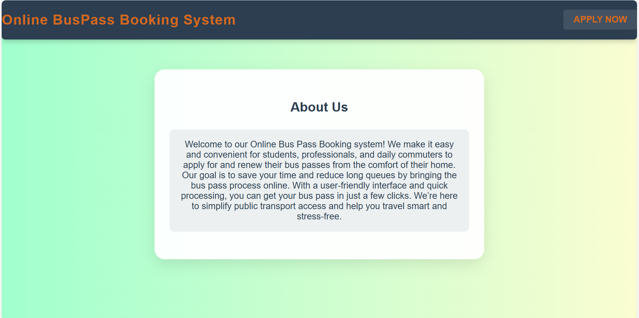

Online Bus Pass Booking System - User Dashboard

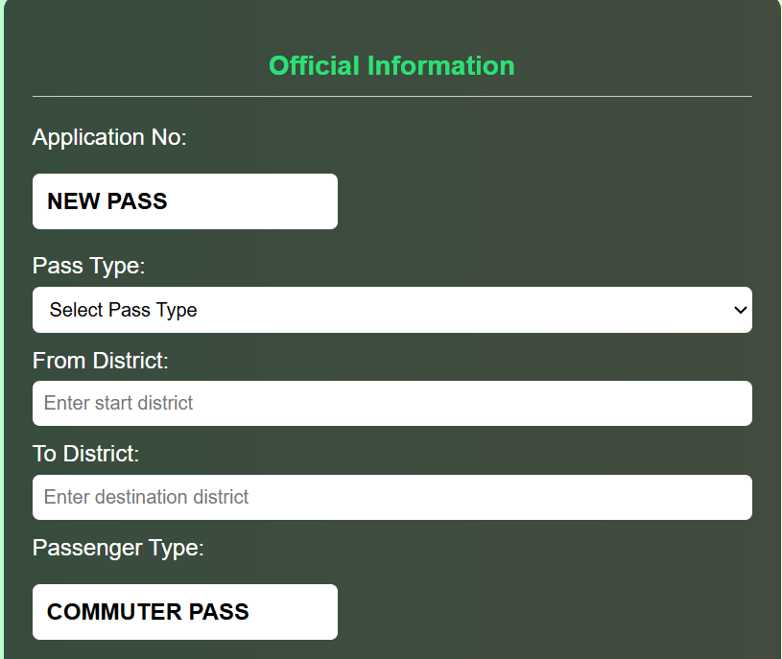

Bus Pass Registration Form

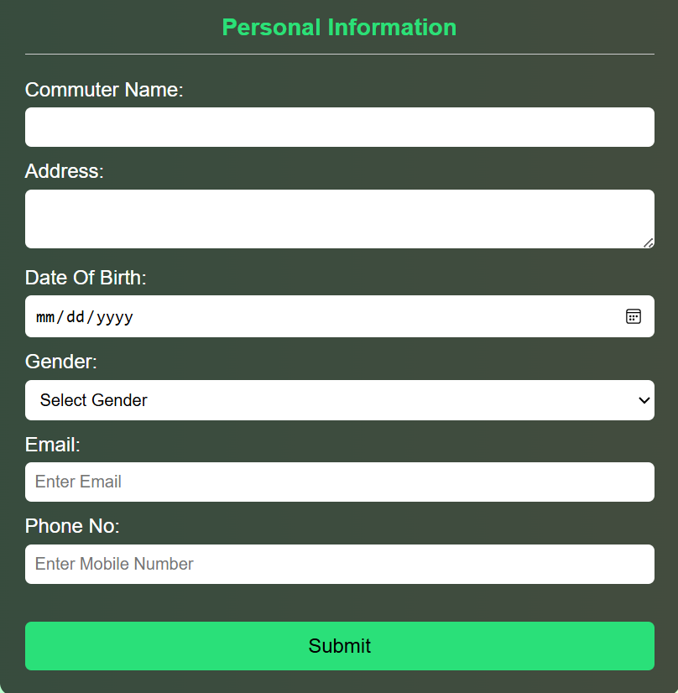

Online Bus Pass Booking System - About Us

## 5. CONCLUSION

## The Online Bus Pass Management System is an efficient, user-friendly web application designed to simplify and automate the bus pass application process for commuters and administrators. By replacing outdated manual processes, this system allows users to apply for new bus passes, renew existing ones, and track their application status with ease. It offers a streamlined platform that enhances the user experience by providing quick access to available passes, automated application processing, and transparent communication about application statuses.

## Through a structured application process, commuters can easily apply for various bus passes, such as student passes, commuter passes, and monthly passes, and receive timely updates on their application progress. The system is designed with role-based access, ensuring that users only have access to the features relevant to their role, which enhances security and operational control.

## For administrators, the system offers a centralized dashboard to manage bus pass applications efficiently. With features like real-time application tracking, status updates, and automatic notifications, the system reduces manual tasks, improves accuracy, and boosts productivity within the administration team.

## Technically, the Online Bus Pass Management System is a responsive, modular, and scalable solution, built with modern web technologies like HTML, CSS, and JavaScript. It ensures compatibility across various devices, making it easily accessible for all users. The system’s modular architecture allows for easy future enhancements, such as the integration of payment gateways for online transactions, mobile app support, and the addition of new bus pass categories.

## By digitizing the bus pass process, the system not only simplifies daily commuting for users but also enhances operational transparency and data management for administrators.

## 6. BIBLIOGRAPHY

1. OpenAI: "GPT-3: Language Models for Text Generation." https://[www.openai.com](http://www.openai.com/)
2. GeeksforGeeks: "Computer Science Portal." [https://www.geeksforgeeks.org](https://www.geeksforgeeks.org/)
3. YouTube: “Various Tutorials and Educational Content." https://[www.youtube.com](http://www.youtube.com/)